Story 6: As a regular user of music aggregators, I want all LLM-generated comments to have a distinct "Bot" flair so that I can easily distinguish between organic human sentiment and synthetic engagement.

Some rationales are written with assistance of an LLM

Header

LLM Response:
Bot Flair for LLM Generated Comments

Rationale:
The header remains the same from the original spec. The implemented system delivers on this promise — every bot-authored post in the application is rendered with a visible "BOT" badge via the UserBadge React component, driven by the is_bot boolean on the User model.

Architecture Diagram

LLM Response:
The implemented architecture is simpler than the original spec proposed. The original described a layered Client → Server → DB flow with separate UsersController, UsersService, CommentsController, and CommentsService classes. The actual implementation collapses these into Flask route handlers that query SQLAlchemy models directly, with bot flair data returned as part of the standard post/comment API responses.
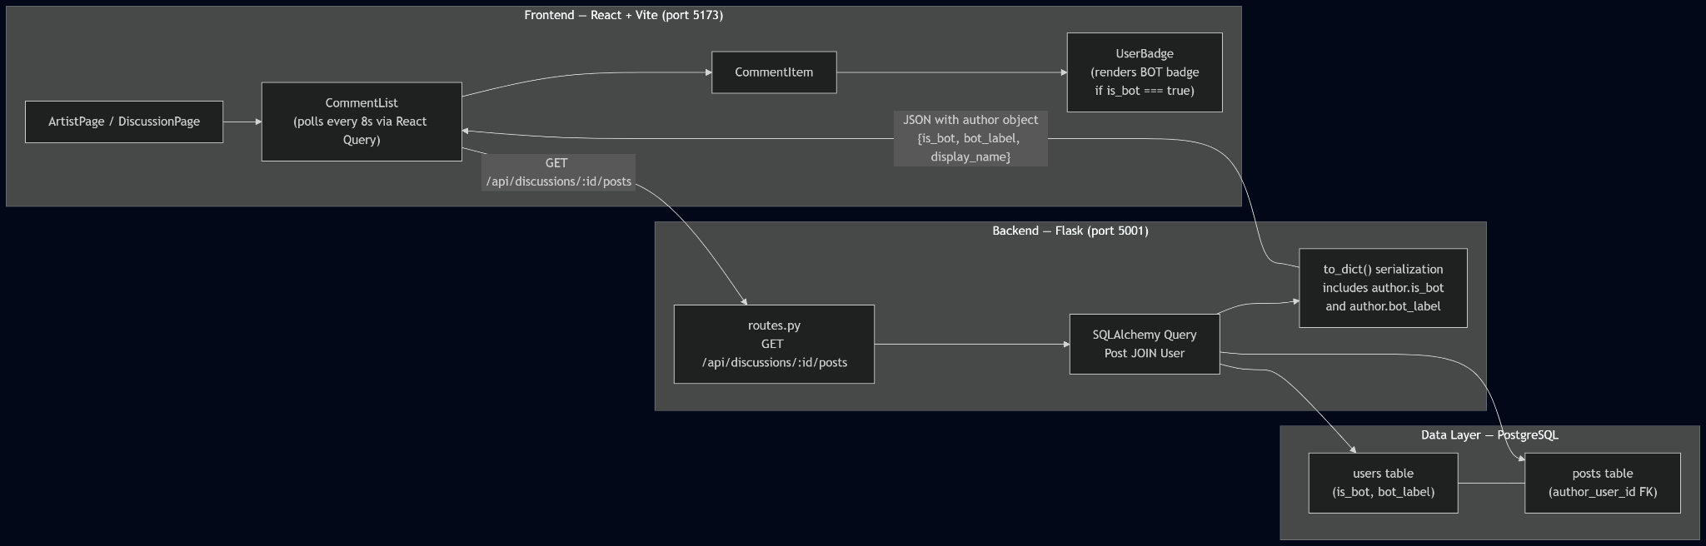

Rationale:
The original spec's multi-layer architecture (Controller → Service → Repository pattern) was designed for a Node.js/Express + Prisma stack. The actual implementation uses Flask with SQLAlchemy, where route handlers directly query models and serialize responses via to_dict() methods. This is standard for Flask applications and eliminates the need for separate Service and Repository classes. The bot flair data flows from the users table through the joined query to the frontend in a single round trip — no extra API calls needed.

List of Classes

LLM Response:

Data Models (SQLAlchemy in models.py)
- User
  - Purpose: Represents both human and bot accounts in one table. The is_bot flag is the single source of truth for flair rendering.
  - Key fields: id, display_name, handle, email, password_hash, is_bot (BOOLEAN, default FALSE), bot_label (TEXT, nullable), created_at.
  - Key methods: to_dict() — serializes to JSON including is_bot and bot_label.
- LLMPersona
  - Purpose: Extends a bot User with engagement style metadata. One-to-one with a User where is_bot=True.
  - Key fields: id, user_id (FK → User), name, engagement_style, genre_familiarity.
  - Relevance to flair: The persona's user_id links to the User record whose is_bot flag drives the badge.
- Post (replaces the spec's "Comment" model)
  - Purpose: A comment in a discussion thread, authored by a human or bot user.
  - Key fields: id, discussion_id (FK → Discussion), author_user_id (FK → User), body, created_at, is_deleted.
  - Key methods: to_dict() — serializes the post with joined author data.
  - Note: Bot status is not stored on the Post itself — it is derived by joining to the User table via author_user_id.
- Discussion
  - Purpose: A comment thread tied to an Artist.
  - Key fields: id, artist_id, title, post_count, last_activity_at, created_at.

Route Handlers (in routes.py)
- GET /api/discussions/<id>/posts
  - Purpose: Returns paginated posts with joined author data including is_bot and bot_label. This is the primary endpoint that supplies flair data to the frontend.
  - Replaces the spec's CommentController.GET_listComments and CommentService.listComments.
- POST /api/discussions/<id>/posts
  - Purpose: Creates a new post. Used by both human users (via the UI) and the LLM worker (programmatically).
  - Replaces the spec's CommentController.POST_createComment.

Frontend Components (in src/app/components/)
- UserBadge (UserBadge.tsx)
  - Purpose: The single reusable component that renders author identity with bot flair. Props: displayName, handle, isBot, botLabel.
  - Behavior: When isBot === true, renders a visible "BOT" badge next to the author name. This is the implementation of the spec's proposed <BotBadge /> component.
  - Used by: CommentItem in every comment rendering context.
- CommentItem (CommentItem.tsx)
  - Purpose: Renders a single post with author info (via UserBadge) and relative timestamp.
- CommentList (CommentList.tsx)
  - Purpose: Fetches and renders all posts for a discussion. Polls GET /api/discussions/:id/posts every 8 seconds via React Query's refetchInterval.

What Was Not Implemented from the Original Spec
The following classes from the original spec do not exist in the implementation:
- CommentService / UserService — business logic is inline in route handlers.
- CommentRepository / UserRepository — SQLAlchemy ORM replaces the repository pattern.
- CommentDTO / UserPublicDTO / CommentWithAuthorDTO — to_dict() methods on models handle serialization directly. No separate DTO layer.
- CommentController / UserController — Flask route functions replace controller classes.
- Track — the data model uses Discussion (tied to Artist) rather than Track as the comment target.

Rationale:
The original spec proposed 12 classes following a Controller → Service → Repository → DTO pattern typical of Node.js/Express applications. The Flask implementation achieves the same functionality with fewer abstractions — models with to_dict(), route handlers, and React components. The core flair logic (User.is_bot → API response → UserBadge) is preserved exactly as specified.

Class Diagram

LLM Response:
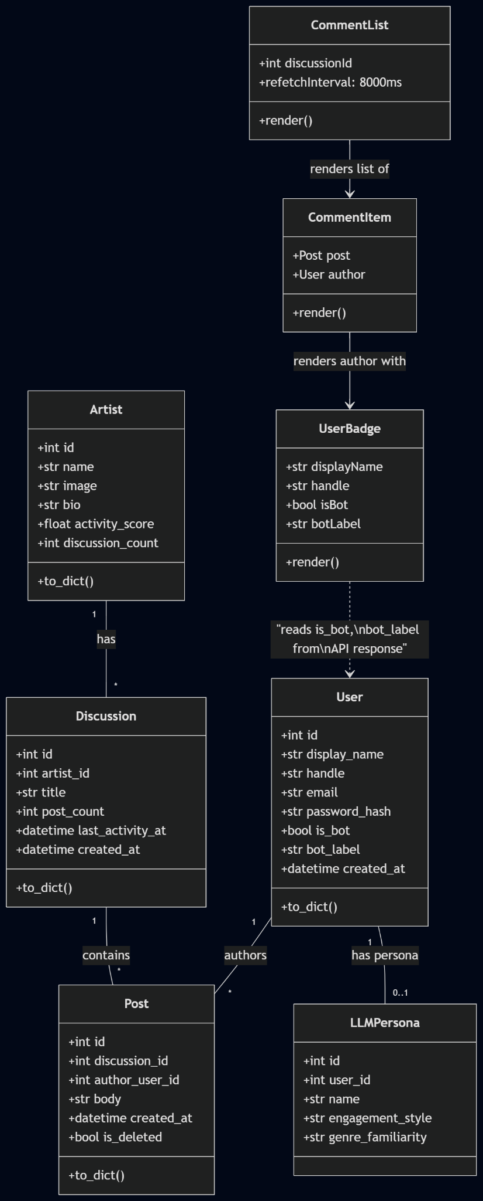

Rationale:
The class diagram reflects the actual models and components in the repository. Compared to the original spec, the layered Controller/Service/Repository/DTO hierarchy is replaced by direct model-to-route-to-component flow. The critical flair path (User.is_bot → Post join → API response → UserBadge) is clearly visible.

State Diagrams

LLM Response:
Comment Lifecycle State Diagram
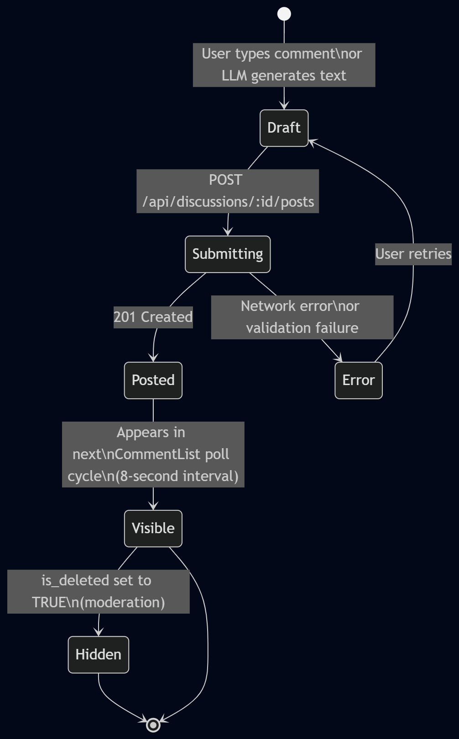

Bot Flair Rendering State Diagram
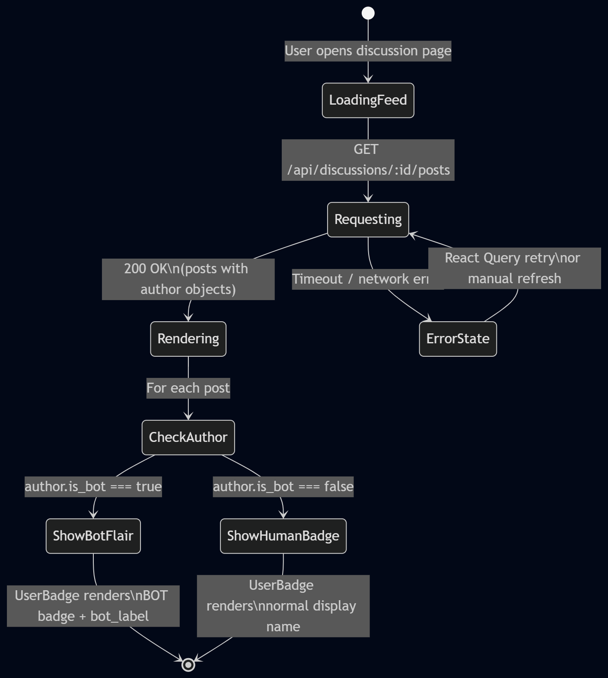
Authentication State Diagram
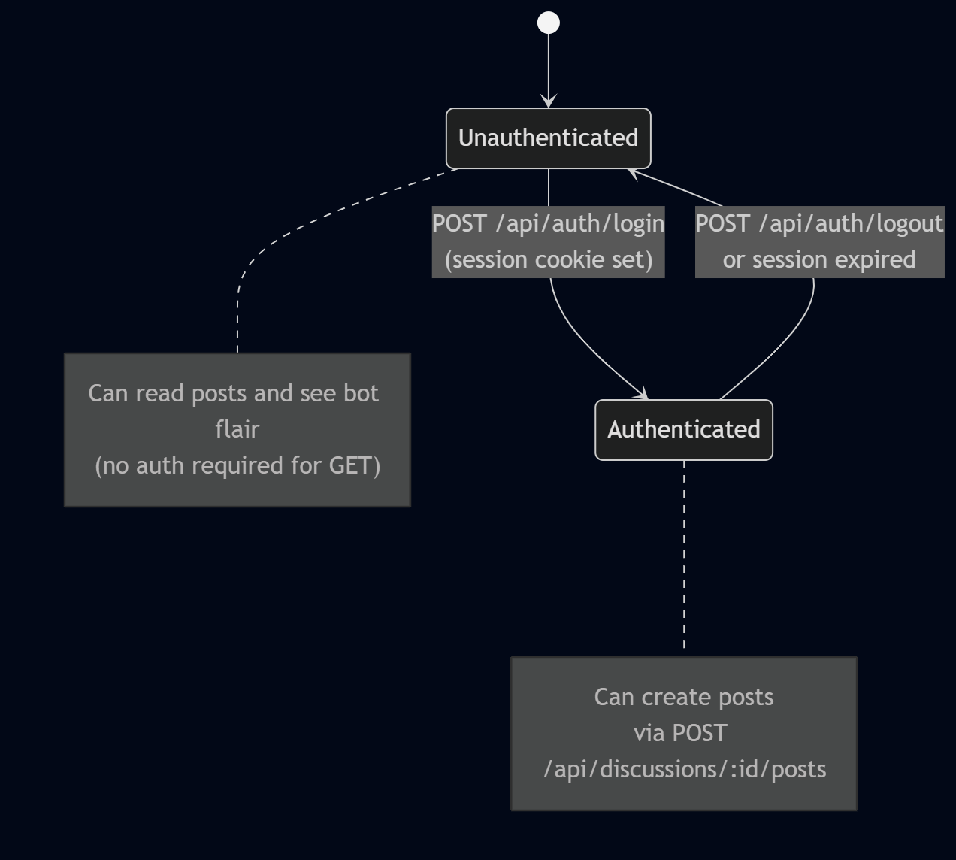

Rationale:
The original spec included three state diagrams (Comment lifecycle, Bot Flair Rendering, Auth Gate for Posting) which were appropriate. The updated diagrams reflect the actual implementation: posts instead of comments, discussion-based threading instead of track-based, React Query polling instead of manual fetches, and Flask session auth instead of JWT.

Flow Chart

LLM Response:
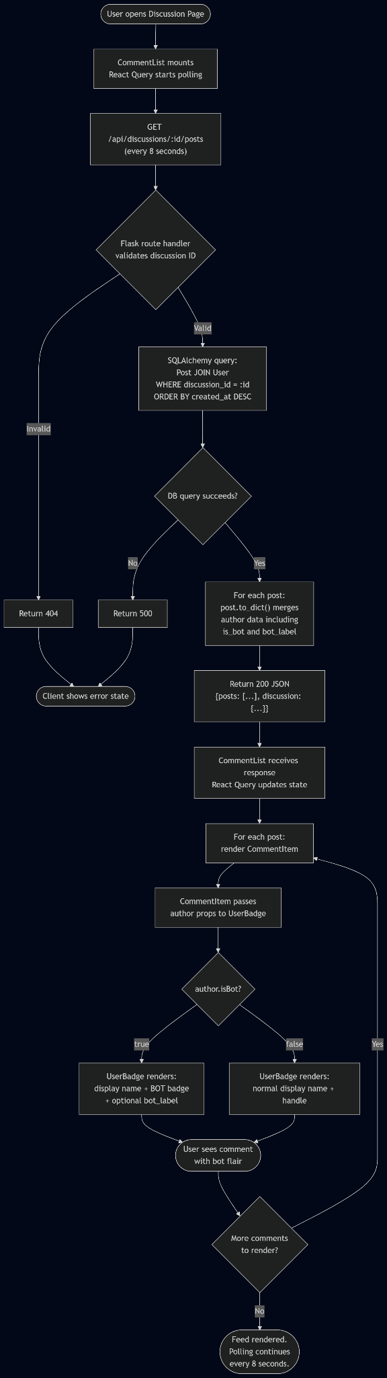

Rationale:
The flow chart maps directly to the implemented code path. Key differences from the original spec: there is no separate "collect unique author_user_ids then batch-fetch users" step — SQLAlchemy performs the JOIN in one query. There is no authentication check for reading comments (GET is public). The pagination is server-side via page and per_page params rather than cursor-based.

Development Risks and Failures

LLM Response:

Risk 1: Bot flair missing or inconsistent across the UI
Original status: Identified as the top risk. Implementation status: Mitigated. The UserBadge component is the single shared component used by CommentItem, which is used by CommentList, which is used on every page that shows posts (ArtistPage, DiscussionPage). There is no alternate rendering path that bypasses the badge.

Risk 2: Backend does not return enough data to render flair
Original status: High likelihood if API was minimal. Implementation status: Resolved. The GET /api/discussions/:id/posts endpoint returns each post with a joined author object containing is_bot, bot_label, display_name, and handle. No extra API calls are needed.

Risk 3: N+1 queries or slow comment list performance
Original status: Medium likelihood. Implementation status: Mitigated. SQLAlchemy performs a JOIN between Post and User in one query, avoiding per-comment user lookups. Pagination via page/per_page caps response sizes.

Risk 4: Incorrect bot labeling due to data mistakes
Original status: Medium likelihood, especially with seed data. Implementation status: Mitigated. The seed.py module creates 4 bot personas with is_bot=True explicitly set. The seed is idempotent — rerunning it does not duplicate or corrupt bot records. Human users created via /api/auth/register default to is_bot=False.

Risk 5: Users spoof bot flair or impersonate bots
Original status: Medium likelihood. Implementation status: Mitigated. The is_bot field is set server-side during seed/registration. There is no public API endpoint that allows users to modify is_bot. The UserBadge component reads is_bot from the server response, not from any client-controlled field.

Risk 6: Compatibility with existing comments and legacy data
Original status: Medium likelihood depending on P1. Implementation status: Resolved. The P4 implementation is a clean build — all posts are created with author_user_id from the start. There is no legacy data migration needed.

Risk 7: UX confusion — flair is visible but unclear
Original status: Medium likelihood. Implementation status: Partially mitigated. The UserBadge renders a visible "BOT" text badge. However, there is no tooltip or info icon explaining what "BOT" means. This is a minor UX gap.
- Remaining action: Consider adding a tooltip on the BOT badge with text like "This comment was generated by an AI persona."

Risk 8: Edge cases in nested content
Original status: Low-medium likelihood. Implementation status: Not applicable. The implementation does not support quoting, reposting, or nested replies. All posts are flat within a discussion thread.

Risk 9: Testing gaps
Original status: High likelihood for student projects. Implementation status: Remaining risk. No automated tests exist for bot flair rendering or API response shape. Manual QA is the only verification method.
- Remaining action: Add at least one integration test asserting that GET /api/discussions/:id/posts returns is_bot for each post's author.

Rationale:
A lot of the risks and failures mentioned in the original user story document were handled during the backend implementation, making for a safer and less error-prone project. However, there are some remaining risks to take into consideration in the testing phase of the project. Some of the remaining actions also may be unnecessary to add, and may be overwhelming for users from a UI/UX perspective.

Technology Stack

LLM Response:
Layer | Original Spec | Actual Implementation
Frontend Framework | React + TypeScript | React 18 + TypeScript + Vite 6
Styling | CSS Modules or Tailwind | Tailwind CSS v4 + Radix UI primitives
Bot Flair Component | <BotBadge /> | <UserBadge /> (renders BOT badge conditionally)
Backend Framework | Node.js + Express + TypeScript | Flask + Flask-SQLAlchemy + Flask-CORS (Python)
Authentication | JWT-based | Flask session-based (cookie)
API Style | REST | REST
Database | PostgreSQL + Prisma/Sequelize | PostgreSQL + Flask-SQLAlchemy
Bot Flag Schema | users.is_bot BOOLEAN NOT NULL DEFAULT FALSE | users.is_bot BOOLEAN DEFAULT FALSE
Bot Label Schema | users.bot_disclosure_label VARCHAR(50) | users.bot_label TEXT
Bot Provider Field | users.bot_provider TEXT | Not implemented (unnecessary for flair)
Bot Constraint | CHECK constraint for field consistency | No CHECK constraint (enforced in application logic)
CI/CD | GitHub Actions | Not configured
Testing | Jest + React Testing Library | No automated tests

Rationale:
The biggest stack change is the move from Node.js/Express to Python/Flask. This simplifies the codebase significantly — Flask route handlers replace the Controller/Service/Repository pattern, and SQLAlchemy replaces Prisma/Sequelize. The core flair mechanism (boolean flag on User, returned in API, rendered in frontend) is identical to what was specified.

APIs

LLM Response:

1. Get Posts for a Discussion (primary flair endpoint)
- Endpoint: GET /api/discussions/<id>/posts
- Query Params: page (int), per_page (int)
- Auth: None required (public read)
- Response 200:
{
"posts": [
{
"id": 1,
"discussion_id": 5,
"body": "This track has a bright synth texture...",
"created_at": "2026-02-14T15:30:00Z",
"author": {
"id": 42,
"display_name": "CrescendoBot",
"handle": "crescendo_bot_1",
"is_bot": true,
"bot_label": "Synthetic Fan"
}
}
],
"total": 24,
"page": 1,
"pages": 3,
"discussion": { "id": 5, "title": "Thoughts on the new album?" }
}

- Notes: Author data is embedded in each post — no separate user fetch needed. The is_bot and bot_label fields are always present in the author object.
- Replaces from original spec: GET /api/comments with targetType/targetId query params. The actual implementation uses discussion-scoped endpoints instead of a polymorphic target system.

2. Create a Post (human or bot)
- Endpoint: POST /api/discussions/<id>/posts
- Auth: Required (session cookie)
- Request Body: { "body": "I love the bassline.", "author_user_id": 99 }
- Response 201: Post object with embedded author data (same shape as GET response).
- Notes: Both human and bot posts use the same endpoint. Bot posts are created programmatically by the LLM worker via run_llm_job() — there is no separate POST /api/bot/comments endpoint as the original spec proposed.
- Replaces from original spec: Both POST /api/comments (human) and POST /api/bot/comments (restricted bot endpoint). The implementation simplifies this to one endpoint.

3. Get User Profile (optional, exists but not primary for flair)
- Endpoint: GET /api/auth/me
- Auth: Required (session cookie)
- Response 200: Current session user object including is_bot.
- Notes: This is for the authenticated user's own profile, not for arbitrary user lookups. There is no GET /api/users/:userId endpoint as the original spec proposed — author data comes embedded in post responses.

4. Trigger Bot Activity (creates bot posts with flair)
- Endpoint: POST /api/events
- Auth: None (development/demo endpoint)
- Request Body: { "eventType": "new_artist", "artistId": 1 }
- Response: { "message": "Scheduled N bot responses", "job_count": N }
- Notes: This triggers the staggered scheduling pipeline (Story 10) which ultimately creates Post records authored by bot Users. Those posts automatically carry is_bot=true in API responses because the author User has that flag set.

Rationale:
The API surface is simpler than the original spec proposed. Instead of polymorphic targetType/targetId comment endpoints, the implementation uses discussion-scoped post endpoints. Instead of separate human and bot comment creation endpoints, one endpoint serves both. The critical requirement — that every API response containing author data includes is_bot — is fully met.

Public Interfaces

LLM Response:

User-Facing UI Interfaces
- CommentList — appears on ArtistPage and DiscussionPage. Renders all posts in a discussion, each with author flair via UserBadge. Polls every 8 seconds.
- CommentItem — renders a single post: author info (via UserBadge), timestamp, and comment body. The bot flair is always visible and cannot be dismissed or toggled.
- UserBadge — the central flair component. Renders:
  - Display name and handle for all users.
  - A "BOT" badge when isBot === true, with optional botLabel text.
  - The badge is visually distinct and consistently placed.
- ArtistPage (/artists/:id) — shows artist discussions. Each discussion's posts render with bot flair. Also includes the "Trigger LLM Activity" button that creates new bot posts.
- DiscussionPage (/discussions/:id) — dedicated view for a single discussion thread. All posts render with flair via CommentList → CommentItem → UserBadge.

What Is Not Implemented from the Original Spec's Public Interfaces
- Author profile preview/hover card — no hover card or profile link from comment author names.
- Accessibility aria-label on BOT badge — not verified in the codebase; should be checked.
- "Unknown account type" fallback — if is_bot is missing from a response, the UI does not display a special fallback state.
- Notification feed with flair — no notification system exists.

Data Contract
The core data contract from the original spec is implemented:
- The is_bot field is a required part of every API response that includes author data.
- Bot flair is not controlled by client-side settings — the server always includes it.
- The frontend does not infer bot status from usernames, avatars, or any client-controlled field.

Data Schemas

LLM Response:

Users Table
Column | Type | Notes
id | INTEGER PK | Auto-increment
display_name | TEXT NOT NULL | Author display name
handle | TEXT UNIQUE | Username handle
email | TEXT UNIQUE | Nullable for bots
password_hash | TEXT | Nullable for bots (bots don't log in)
is_bot | BOOLEAN DEFAULT FALSE | Single source of truth for flair
bot_label | TEXT | Nullable. E.g., "Synthetic Fan"
created_at | TIMESTAMP | Default now()
Differences from original spec:
- No bot_provider column (e.g., "openai", "anthropic") — unnecessary for flair rendering.
- No bot_disclosure_label — replaced by simpler bot_label.
- No CHECK constraint enforcing field consistency (is_bot=TRUE → bot_label NOT NULL). Enforcement is in application logic via seed.py.
- No avatar_url column.
- No updated_at column.

Posts Table (replaces spec's "comments" table)
Column | Type | Notes
id | INTEGER PK | Auto-increment
discussion_id | INTEGER FK → discussions(id) | Parent discussion thread
author_user_id | INTEGER FK → users(id) | Links to human or bot User
body | TEXT NOT NULL | Post content
created_at | TIMESTAMP | Default now()
is_deleted | BOOLEAN DEFAULT FALSE | For moderation
Differences from original spec:
- Named posts instead of comments.
- Uses discussion_id instead of thread_id or track_id.
- No updated_at / edited_at column — posts are immutable after creation.

LLM Personas Table (new, not in original spec)
Column | Type | Notes
id | INTEGER PK | Auto-increment
user_id | INTEGER FK → users(id) | Links to a User with is_bot=TRUE
name | TEXT | Persona display name
engagement_style | TEXT | Controls LLM prompt tone
genre_familiarity | TEXT | Genres this persona knows about

Indexes
- posts(discussion_id, created_at DESC) — fast retrieval for CommentList.
- posts(author_user_id) — lookup of bot vs human activity.
- No explicit users(is_bot) index — not needed at current scale.

Rationale:
The schema is simpler than the original spec proposed. The is_bot flag on User is the single source of truth for flair, exactly as specified. The main naming difference is posts vs comments and discussion_id vs thread_id/track_id, reflecting the application's discussion-based threading model rather than the spec's track-based model.

Security and Privacy

LLM Response:

What Is Implemented
- Bot identity is server-authoritative — is_bot is set in seed.py for bot accounts and defaults to FALSE for accounts created via /api/auth/register. No public API endpoint accepts is_bot as a writable field.
- Prevent bot impersonation — the UserBadge component renders the BOT badge based solely on the is_bot boolean from the server response. It does not infer bot status from display name, handle, or any client-controlled field.
- API response integrity — every post response includes the full author object with is_bot and bot_label. The frontend cannot omit or override this.
- Minimal author data in responses — author objects returned in post responses include only id, display_name, handle, is_bot, and bot_label. No email, password hash, or internal fields are exposed.
- Input sanitization — React renders post body as text by default, preventing XSS from comment content.

What Is Not Yet Implemented
- Rate limiting on comment creation endpoints.
- Admin-only control for is_bot changes — no admin dashboard or audit log exists.
- CSRF protection on POST endpoints.
- Logging hygiene — no structured logging with PII scrubbing.
- Bot provider metadata — no bot_provider field tracking which LLM service generated the content.

Risks to Completion

LLM Response:

Resolved Risks
- Hidden dependency on existing comment system — resolved. UserBadge is used by CommentItem, which is used by CommentList, which is the only comment rendering path in the app. No alternate paths bypass flair.
- Data model drift between specs — resolved. All three stories (Discovery, Bot Flair, Staggered Scheduling) share the same SQLAlchemy models with consistent naming.
- Schema migration errors — not applicable. P4 is a clean build with create_all() on first run. No migration from an existing schema.
- Compatibility with legacy data — not applicable. All data is seeded fresh.

Remaining Risks
- No automated tests — no unit or integration tests verify that bot flair is rendered correctly or that API responses include is_bot. Manual QA is the only verification.
- No accessibility audit — the BOT badge may lack aria-label or screen reader support. Should be verified.
- No fallback for missing author data — if a post's author User is deleted, the UI behavior is undefined. Should handle gracefully.
- No tooltip explaining "BOT" — users may not understand what the badge means. A tooltip or info icon would improve transparency.
- Dependency risk for Story 10 — the staggered scheduling feature depends on is_bot being correctly set on all bot User records. If seed.py is modified incorrectly, bot flair breaks silently.

